A

Synopsis/Project Report

On

**Traditional Game**

Submitted in partial fulfillment of the requirement for the IIIrd semester

**Bachelor of Technology**

By

**MOHIT SINGH KHATI**

**NEERAJ KOSHYARI**

**PRIYANSHU**

Under the Guidance of

**Mr. Ravindra Koranga**

**Assistant Professor**

**Department of CSE**



**DEPARTMENT OF COMPUTER SCIENCE & APPLICATIONS**

**GRAPHIC ERA HILL UNIVERSITY, BHIMTAL CAMPUS**

**SATTAL ROAD, P.O. BHOWALI,**

**DISTRICT- NAINITAL-263132**

**2022 – 2023**

## GUIDELINES FOR SYNOPSIS

* **Students’ Declaration**
* **Certificate**
* **Acknowledgement**
* **Contents**
* **Introduction**

**STUDENT’S DECLARATION**

We **MOHIT SINGH KHATI, NEERAJ KOSHYARI, PRIYANSHU** hereby declare the work, which is being presented in the project, entitled “**Traditional Game”** in partial fulfillment of the requirement for the award of the degree **B. Tech** in the session **2022-2023**, is an authentic record of our own work carried out under the supervision of **“Mr. Ravindra Koranga”, Assistant Professor, Department of CSE, Graphic Era Hill University, Bhimtal.**

The matter embodied in this project has not been submitted by us for the award of any other degree.

Date: ………… …………………..

(Full signature of students)

**CERTIFICATE**

**The project report entitled “Traditional Game” being submitted by MOHIT SINGH KHATI, NEERAJ KOSHYARI, PRIYANSHU to Graphic Era Hill University Bhimtal Campus for the award of bonafide work carried out by them. They have worked under my guidance and supervision and fulfilled the requirement for the submission of report.**

**(…………………) (……………………)**

**Project Guide (HOD, CSE Dept.)**

**ACKNOWLEDGEMENT**

We take immense pleasure in thanking Honorable **“Mr. Ravindra Koranga”**(**Assistant Professor**, **CSE, GEHU Bhimtal Campus**) to permit usand carry out this project work with his excellent and optimistic supervision. This has all been possible due to his novel inspiration, able guidance and useful suggestions that helped me to develop as a creative researcher and complete the research work, in time.

Words are inadequate in offering our thanks to GOD for providing me everything that we need. We again want to extend thanks to our President **“Prof. (Dr.) Kamal Ghanshala”** for providing us all infrastructure and facilities to work in need without which this work could not be possible.

Many thanks to Professor **“Dr. ManojChandra Lohani”** (Director Gehu Bhimtal), other faculties for their insightful comments, constructive suggestions, valuable advice, and time in reviewing this theis.

Finally, yet importantly, we would like to express my heartiest thanks to our beloved parents, for their moral support, affection and blessings. We would also like to pay my sincere thanks to all my friends and well-wishers for their help and wishes for the successful completion of this research.

**MOHIT SINGH KHATI**

**NEERAJ KOSHAYRI**

**PRIYANSHU**

**INTRODUCTION**

Kaooa, otherwise known as "Baagh And Bakri" is a traditional game from India. Like [Len Choa](https://www.whatdowedoallday.com/len-choa-leopards-and-tiger-game/) *(*"Tiger and Leopards"*)* and [Fox and Geese](https://www.whatdowedoallday.com/fox-and-geese/), it is a hunt game. Hunt games often pit one player with one token against a second player who has multiple tokens. As you can tell, the tokens usually are named after animals, a fun dynamic that adds a little imaginative spirit to the game.

Kaooa is unique in that it uses a pentagram, or star-shaped, board, similar to the one person game, [Pentalpha](https://www.whatdowedoallday.com/pentalpha-puzzle/). It is easy to make your own game board.

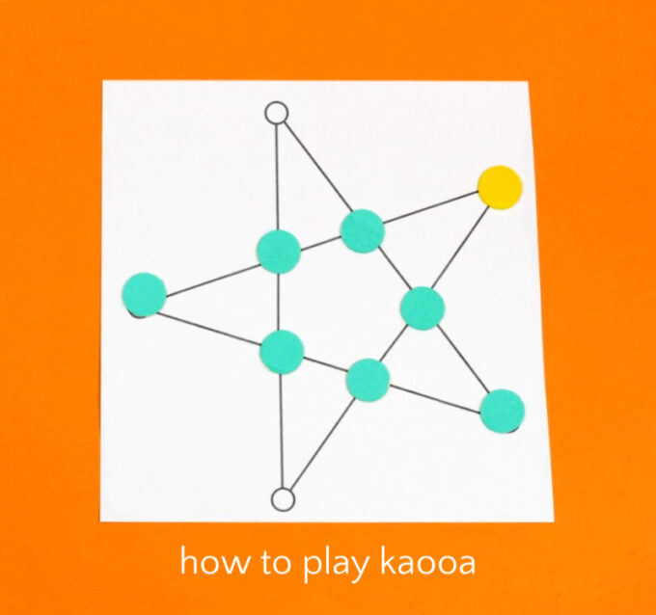

**OBJECTIVE:**

The Bakri objective is to surround the baagh and blockade him from moving. The Baagh objective is to capture any four bakri. He can captures a Bakri by jumping over it.

Instructions

1. **Legal Moves**

Bakris may move from one spot to an adjacent vacant spot. Only one move is allowed per turn. No jumping is allowed for forbakris.  
  
The baagh may move to an adjacent vacant spot. The baagh may also jump a bakri and capture it. Jumps are only allowed in a straight line. Captured bakris are removed from play. The baagh must jump a bakri if the opportunity presents itself. Only one jump per turn.

1. **Bakris go first**

Player 1 places one of their bakri tokens on any of the ten intersections of the game board.

1. **Baagh goes next**

Player 2 places the baagh on any vacant spot.

1. **Bakris continue "drop phase"**

Player 1 one drops his second bakri on a vacant spot. (Note: in the example below, the baagh forced the bakri's second move to be in the corner or else the first bakri would have been vulnerable to capture.)

1. **Baagh moves**

The baagh can now move.

1. **Play continues**

Players alternate turns with the baagh moving along the game board and Player 2 dropping his flock of bakris one by one onto the game board. Only once all seven bakris have been placed on the board can the bakris begin moving.

1. **Winning**

The baagh wins if he captures at least 4 bakris.  
  
The bakris win if they manage to trap the baagh in a way that prevents him from making a legal move. (*In the example below, the baagh has won.*)

**PROBLEM STATEMENT**

Traditional games are chart-topping activities among people who live in rural areas. It has been played by our society for a long time. Nowadays, most of the traditional games are being abandoned by the children of this modern era as the gadgets are more attractive for them.

 There is no doubt that playing traditional games has its own advantages to the players. The main advantage is it can enhance the players thinking skills. We must use our brain’s ability to play some of the traditional games which include memorizing and using our own knowledge.

Playing traditional games also can increase the players’ knowledge. They will be exposed to the new things that they may not learn in class. Thus, these games can be the interesting hobby to the children.

Hence, most of the traditional games require dexterity and body movement such as swinging of the arms and jumping. This encourages players to exercise and improves their eye-hand coordination. The benefits of these traditional games outweigh the benefits of today’s technology. Therefore, we should have more opportunities to play these games in ample time rather than gadgets.

**METHODOLOGY**

**SYSTEM ARCHITECTURE**

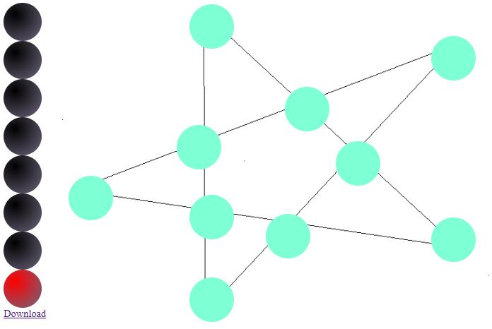

The above figure represents the game page architecture or design. The game page has some this (Above figure) kind of structure. It consists of a game board, moving block and a download menu. The game is simple and easy to play. You don’t have to gain extra knowledge or learn to use this. The functionality is as simple as it views to you.

**DESIGN**

Project design is a major step towards a successful project. A project design is a strategic organization of ideas, materials and processes for the purpose of achieving a goal. Project managers rely on a good design to avoid pitfalls and provide parameters to maintain crucial aspects of the project. Project design is an early phase of the project where a project's key features, structure, criteria for success, and major deliverables are all planned out. The point is to develop one or more designs which can be used to achieve the desired project goals. Stakeholders can then choose the best design to use for the actual execution of the project.

This project has been designed by using HTML (Hyper Text Markup Language), CSS (Cascading Style Sheets) and JavaScript. HTML here act as the main body of the website, CSS helps in designing the body and JavaScript helps in functioning of the body means functioning of the webpage.

**CONCLUSION AND FUTURE SCOPE**

In this project we deal with the Baagh Bakri as well as about The Traditional Games of India. We created a web page regarding the Baagh Bakri game. This work took lots of effort. This web page you can use easily. You can say this webpage is like IQ games.

This web page is going to progress in such a way that if you want to enjoy traditional games on mobile, or want to explore more about the traditional games, you are going to find here.

**REFERENCES**

[1] Freecodecamp – This is a particular website where you can find out such courses. This website really helped me a lot in my project.

[2] W3schools – This is a website which is freely available. You can explore many topics, and your technical doubts here.

[3] You Tube Sources – You Tube in today’s era is one of the best sources to learn any topic.

[4] Github– GitHub is a Git repository hosting service. GitHub also facilitates with many of its features, such as access control and collaboration. It provides a Web-based graphical interface.

Website- [Kaooa: Traditional Abstract Strategy Hunt Game from India (whatdowedoallday.com)](https://www.whatdowedoallday.com/kaooa)